HANTAMBO WOMEN’S ORGANIZATION
PROFILE

RAISING THE STANDARDS OF LIFE FOR RURAL MARGINALISED COMMUNITIES ESPECIALLY WOMEN
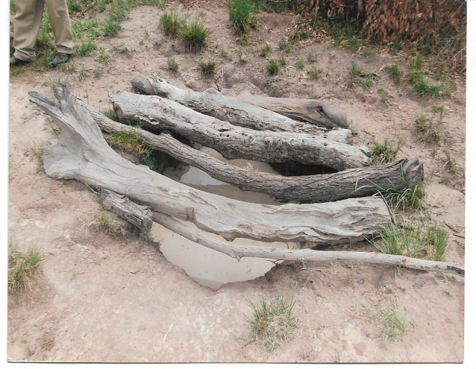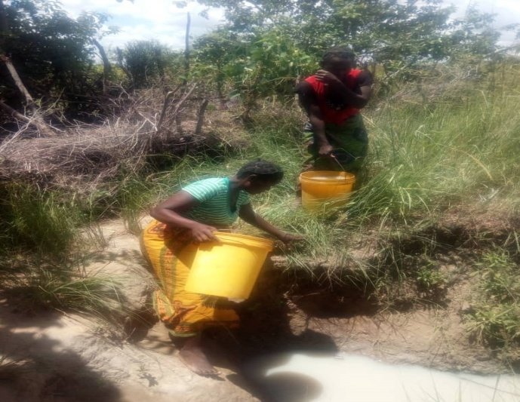
Shallow wells where they were drawing water from

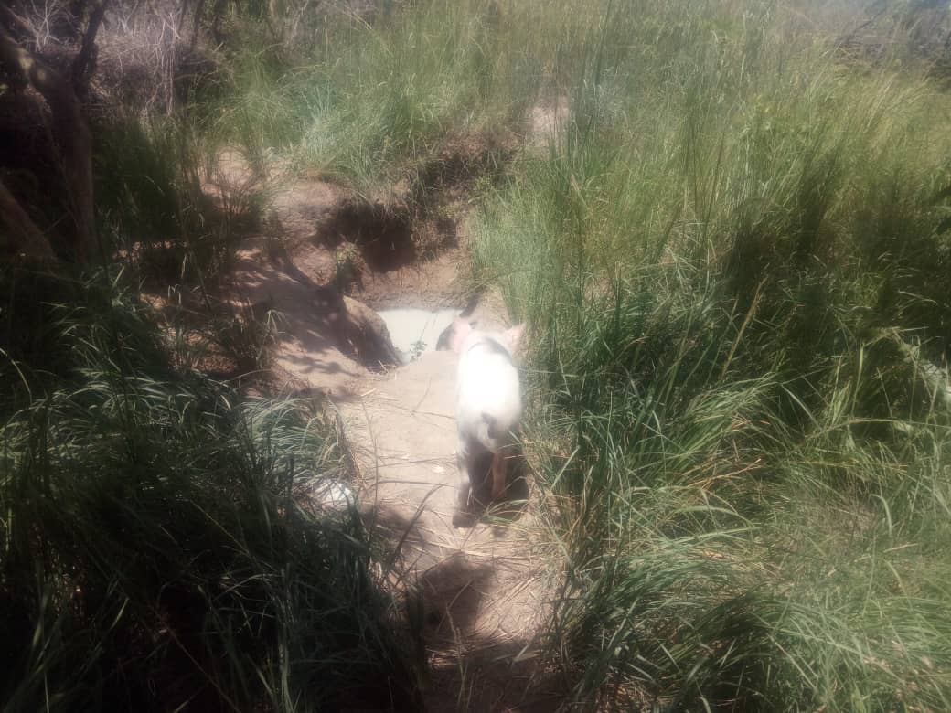
A Pig going to drink at the same well

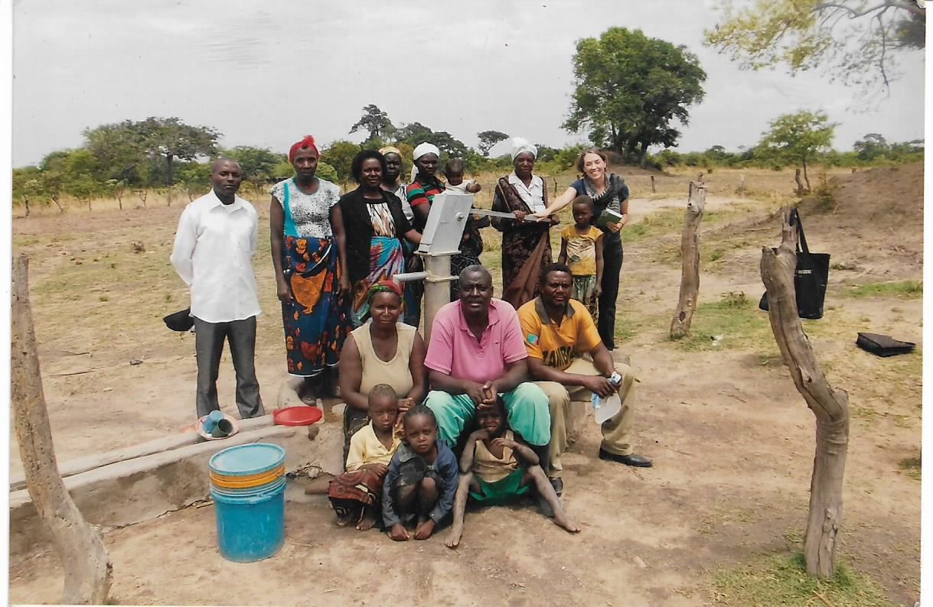
One of the drilled boreholes

ABOUT THE ORGANIZATION
Hantambo Women’s Organization is a registered indigenous community based organization operating in Chikanta and Mapanza chiefdoms of the Southern Province of Zambia run by a non-paid Executive Committee and a Board of Trustee.
The organization was founded in the late 1990s as a women’s club who moved to Chikanta with their husbands in search of fertile farming land. The area used to be a game reserve with no social amenities like schools and health centres. The area does not enjoy any natural water sources like streams or rivers. There were tsetse flies in this are that contributed to the demise of cattle and other livestock. This background triggered the formation of a women’s club to share skills, ideas and knowledge with reflection from the different regions they migrated from to cushion their lives. The HIV pandemic also became one of the compelling reasons for the club to be registered. The increase in membership and activities prompted the club to be re-registered as a Community Based Organization. Currently the organization has four hundred and twenty (420) active members.
There being no natural streams or rivers nor man-made dams in our operational areas, water is scarce and when found it has to be shared with wild and domestic animals. The communities have been depending on one rain-fed crop – maize for their livelihood. With climate change the communities can no longer rely on maize and as an alternative source of income trees are cut and sold for wood fuel or made into charcoal and grass is cut and sold to investors for their grass thatched chalets at lodges. This environmental degradation leaves the area a semi desert.
During the two to three months after rain season (March to June) women grow vegetables for consumption using shallow wells which dry up in July, latest August after which they find it difficult to put food on the table if they did not dry enough vegetables.
Organization Structure
The supreme authority of Hantambo Women’s Organization is the Annual General Meeting (AGM) which comprised of fully paid up members of the organization who are eligible to participate in all the proceedings of the AGM. The AGM makes final decisions related to the organization as defined in the Constitution. Members of the Executive Committee are presented at the Annual General Meeting. The AGM also receives the Annual Financial Report and proposes/approves amendments to the Constitution.
The Executive Committee is the second supreme body charged with responsibility of formulating policy directions for the organization. The Executive Committee comprises of the Executive Chairlady, Vice Chairlady, Secretary and Vice Secretary, Treasurer and Vice Treasurer and four committee members. None of the above are on salary, they work on voluntary basis The Executive Committee members are nominated for a three-year period with possibility of being re-nominated for second and third terms. In line with their responsibilities, they hold quarterly meetings as provided for in the Constitution. There is also an Organization Coordinator who attends the Executive Committee meetings as an ex-official. The organization has a Board of Trustees.
The Organization covers 20 villages in Chikanta and ten in Mapanza with a population of about 1500 people and has 420 members mostly women and youth though men are also on board.
Hantambo Women’s Organization is a membership organization and as such members are actively engaged in program implementations and networking as well as day to day operations of the organization.
1
Mission
To empower marginalised rural community members, especially women and youths through sustainable agricultural practices and environmental awareness, natural resources preservation, and land management.
Vision
Raised standards of life for women, youths and disabled through sustainable agricultural practices, environment awareness and natural resources preservation in Kalomo and Choma Districts.

Organizational Objectives:-
- Empowering the marginalised rural communities, especially women financially, physically and socially to raise their own standard of life and also for the aged and orphans to acceptable levels through sustainable agricultural practices, seed selection and environmental awareness through sensitization using workshops, seminars and talk shows
- Restore lost biodiversity through reforestation, land management and natural resources preservation
- Care at community levels, for people living with HIV/AIDs that they live longer and comfortable
- Provide alternative livelihoods like gardening instead of charcoal burning by drilling boreholes
- Promote gender equality and literacy
- Stop gender based violence

Our values
Transparency and Accountability

Team work

Gender equality

H.W.O

Sustainability

Education

2

Finance
Hantambo Women’s Organization continued service depends on its ability to safeguard and manage effectively and efficiently all donor funds (including locally generated income) entrusted to it. Central to this is a sound structure of financial management and control to maintain both integrity and confidence.
The organization has a Financial Manual specifically designed to suit the accounting and financial management practices and the general principles and essential features are applicable to all resources no matter their source. The Manual is reviewed and updated annually to take into account potential new donor regulations, tax law regulations as well as new developments in the accountancy profession and changes in the organization.
Our partners include UNDP (GEF) Small Grants Programme, American Embassy, Ministry of Community Development and Social Services, Ministry of Foreign Affairs of the Finish Government through Civil Society Environment Fund Phase 2 (CSEF2) and other well wishers.
Our Programming Principles
- We use the bottom up approach which builds on people’s exiting capabilities and strengths
- Provide empowerment interventions thereby build capacities
- Work with stakeholders
- Ensure accountability and promote transparency
- Seek sustainable result.
Our Approach
Hantambo Women’s Organization uses Self Help Groups in every sphere of its work as it promotes the enjoyment of human rights for all vulnerable and marginalised people especially women.
The approach puts equal emphasis on goals of economic, social and financial empowerment of women, youths and people with special needs through self help groups.
Gender Equity Sensitization and Women Empowerment Programme
- Gender equity sensitization programme aims at promoting and encouraging a general understanding of gender related challenges, for instance gender based violence and gender inequalities in decision making positions. We have realised that there cannot be gender equity in marginalised rural women who do not own land, cattle and other valuable properties which by culture are supposed to belong to the men folk. Hence the women need to be empowered to come to the same levels with men and only then can they compete equitably in decision making at family, community, national and international levels.
- Gender Based Violence is addressed by sensitization, prevention, support for survivors and their families and also advocate and promote responsible legal and justice systems.
- Economic Empowerment is to promote wealth creation in communities through formation of self help groups that are given incentives to start activities for food security and income generating.
- Social Empowerment programme emphasizes on individual and community level problem solving or conflict resolution. Groups are encouraged to discuss their private lives at family level or in their communities and develop solutions together in their meetings.

3

- Literacy is encouraged at community levels through adult education to build literate communities through basic adult education with the purpose of reducing illiteracy rates in rural communities. This would help communities to read manuals, insecticide/medicine labels etc and follow instructions
Environment and Natural Resources Management
- Capacity building in Agriculture and Environment Management aims at enabling smallholder farmers improve their knowledge in agriculture and environment management
- Restoration of lost biodiversity through reforestation, land management and natural resources preservation promotes strong participation in environment and natural resources management at grass root level. Alternative livelihoods are introduced, for example, gardening instead of charcoal burning for income generating.
- Sustainable Agriculture Practices.

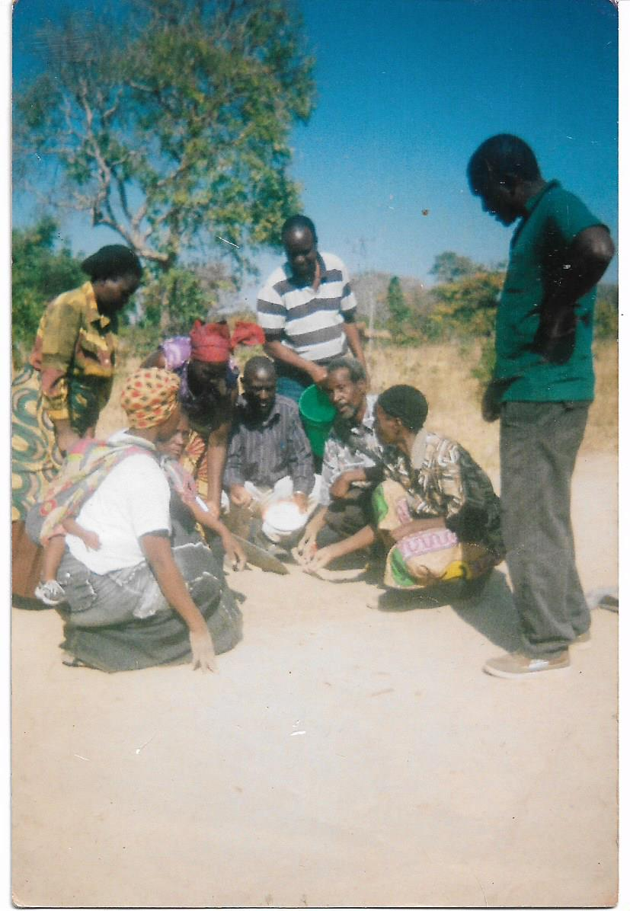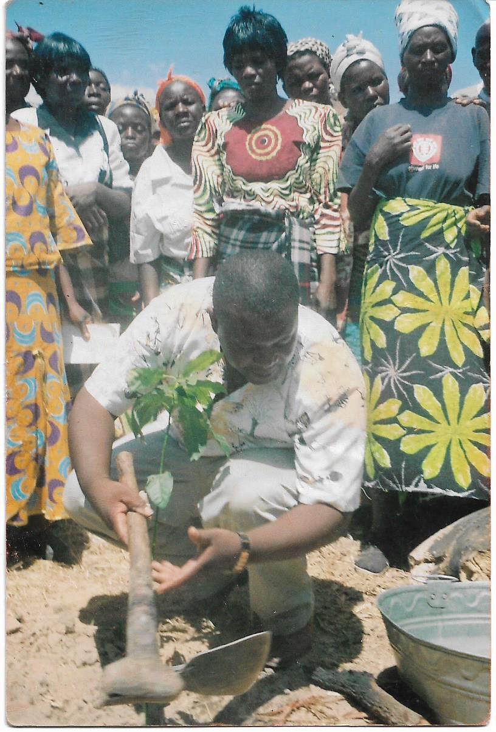
Mixing the soil for nursery tree planting Hon. E. Sing’ombe planting a tree

4
Water and Sanitation
- Hantambo Women’s Organization aims to improve access to safe drinking water and for irrigation purposes especially due to the fact that in our operational areas there are no natural streams or rivers, nor man-made dams. Water is scarce and when found it has to be shared with wild and domestic animals.
- Communities are encouraged to use VIP latrines at each household, dig rubbish pits and build stalls for drying their kitchen utensils.
Networking
Hantambo Women’s Organization networks with a number of CSOs like Provincial Farmers Union, Participatory Ecological Land Use and Management (PELUM Zambia) Southern Province CSO Environmental Hub, Civil Society organization, African NGO Forum and Zambia Chapter for African NGO.
OUR IMPACT
- Empowerment of Rural Marginalised Communities Especially Women and Gender Equality
- Nine (9) boreholes have so far been drilled with six of them fenced and members allocated plots near these boreholes for vegetable and citrus trees irrigation
- 4000 community members accessing safe drinking water.
- One hundred and twenty (120) are growing vegetables giving balanced diet at family level
- Reduced malnutrition in children and people living with HIV/AIDs.
- Increased income through vegetable sales
- More women now have a say in decision making at family, community, national levels and some are now leading cooperative societies in their communities. There cannot be gender equality if women do not own any wealth in form of land, cattle, and other properties as was the case before being empowered.
- Reduction in gender based violence as women who are usually victims can now stand on their own and do not entirely depend on men for survival.
- More women empowered with knowledge and skills in income generating activities.
- Alternative livelihoods

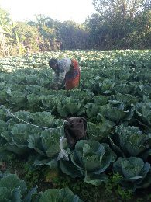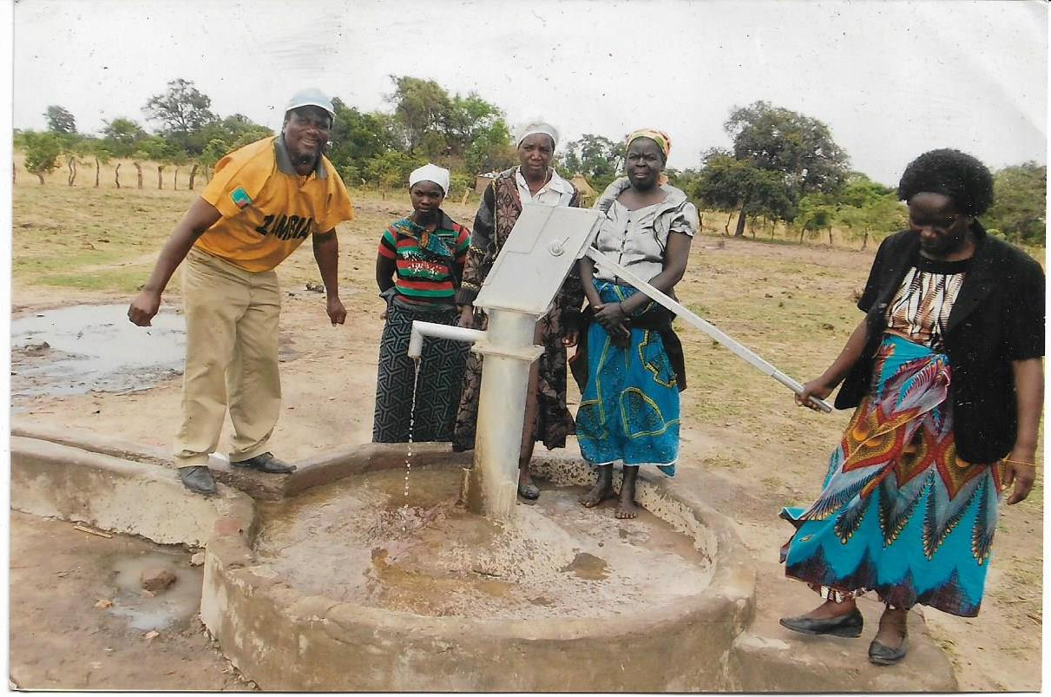
Member’s vegetable garden New Borehole

5

- Management Environment and Natural Resources
- Five districts (Mazabuka, Monze, Pemba, Choma and Kalomo) with about one million people were sensitized on Conservation farming, natural resource management, forest management and seed selection using radio shows
- Improved forest and land management and changed mind set of forest ownership
- Reduced deforestation and soil erosion due to dependence on vegetable growing for income generation than on charcoal burning
- Timber and citrus trees have been planted.
- Village Environment Committees have been formed to take charge of environment and bush fires.
- Community members have been trained in forest management, gardening, conservation farming, seed selection, borehole repairing, land degradation and natural resources preservation
- Won some prizes at district and provincial agricultural shows

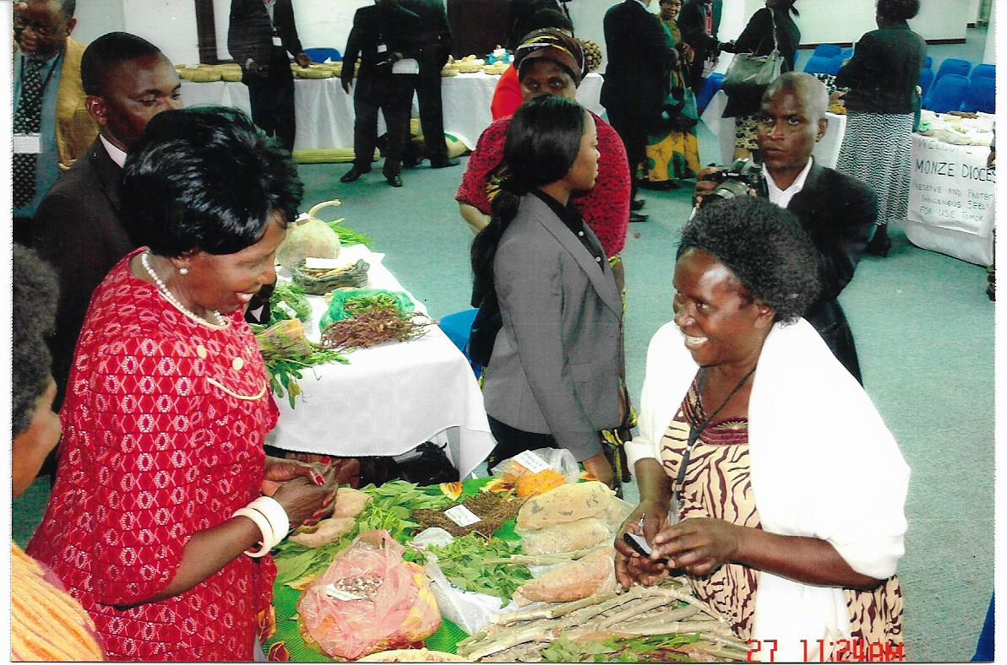
Her Honour the Vice President, Inonge Mutukwa Wina visiting our stand during the
Local Seed Exposure at the Government complex.

6

Water and Sanitation
Drilling of Boreholes
- So far nine (9) boreholes have been sunk and these have gone a long way in reducing water born diseases like diarrheal
- Women spend less time on fetching water and have time to take part in other household chores
- About four thousand (4000) people access safe drinking water
- Improved sanitation at household level.
- Increased stalls for drying kitchen utensils and increased garbage pits

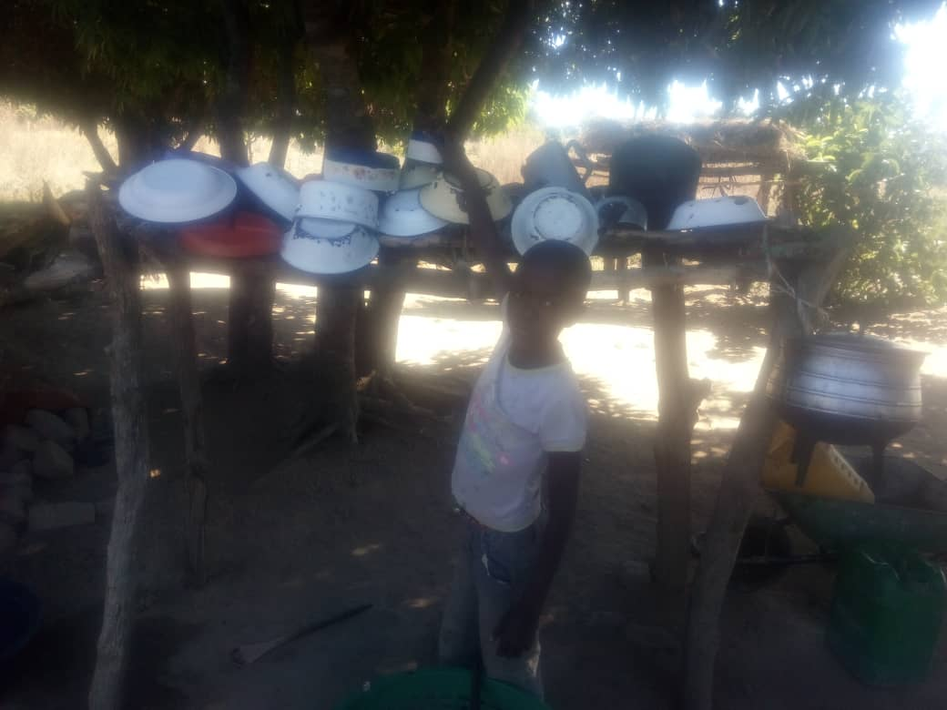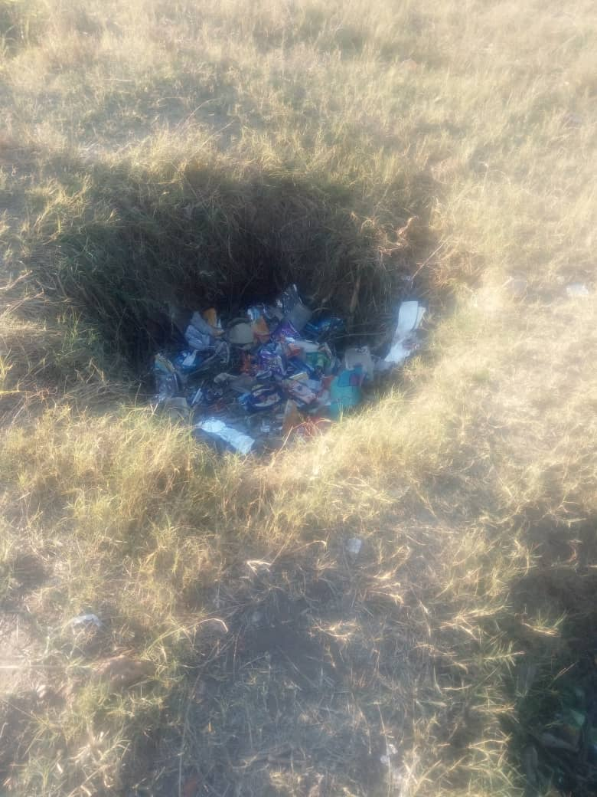
Stall for drying plates Garbage pit

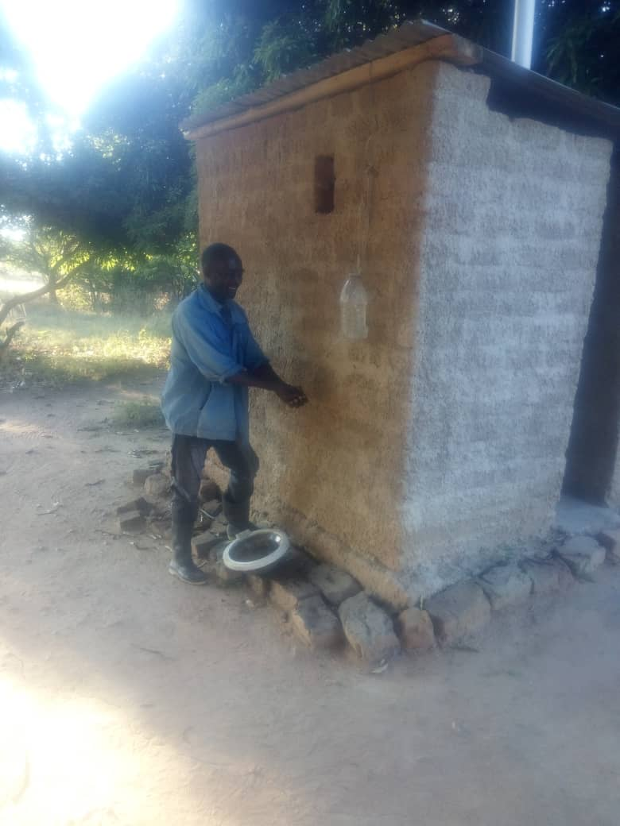

VIP Toilet

7
- Monitoring and Evaluation

- Hantambo Women’s Organization assigns the Programme Officers to coordinate the implementation of the projects and as such, they are responsible to visit, organise and implement and report to the Coordinator on a quarterly basis.
- Annual impact indicators are monitored closely to measure the impact of the projects on beneficiary communities.
- At community level, community workers coordinate and monitor the project implementation in their respective catchment areas. The Coordinator in collaboration with Agriculture Extension Officers from Government and NGOs give technical expertise to ensure that the systems put in place are technically sound.
- The Coordinator writes monthly progress reports for the organization. This includes financial and acquittals.
- At the end of the project, a private consultancy firm is hired to evaluate the project to measure its performance.

For more information contact

Ms Tamar Simuyambala
Coordinator
Hantambo Village
Kasukwe Ward
Kalomo District
Cell: 0977/0965 – 449642
0954-822111

8

